HOW TO CHANGE DISPLAY’S IP ADDRESS

Brief Description

Display communication on the LAN network is performed via Ethernet TCP/IP Lantronix interface module. This module has a fixed MAC address and changeable IP address. To change the IP address please follow the next procedure.

Changing Display’s IP Address

Display was shipped with IP address set to its factory default as specified on the label next to the RJ45 connector on display’s back panel. This IP address can be changed using the following procedure.

- Install the DeviceInstaller application software on your PC.
Simply run the DeviceInstaller installation file - Di32DL_4.2.0.1_Web.exe. This will install the Lantronix DeviceInstaller software on your PC.
Once installed, start this application.

- In the Lantronix DeviceInstaller window verify that the display was found on the network. You should see a Local connection with display’s IP address and XPORT folder (see picture below).

- Click on “Assign IP” button.

- In the Device Identification window, type the display’s MAC address (hardware address) and click Next.
Hardware Address can be seen in the main window next to its IP Address (see picture below).

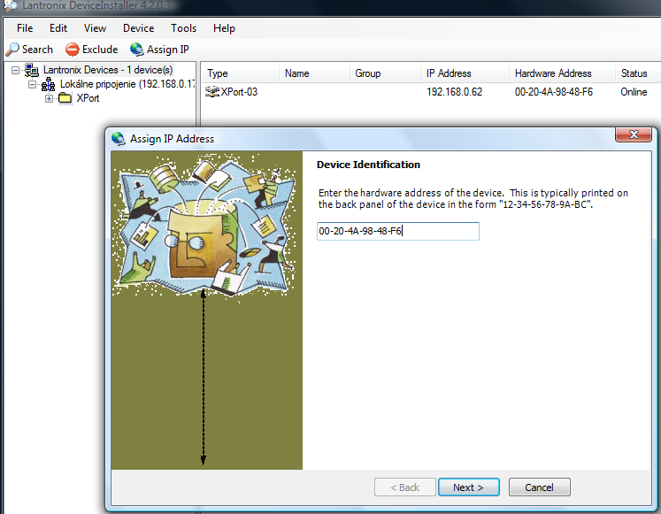

- Check the “Assign a Specific IP Address” option and click Next.
- In the field IP address: change the IP address and click Next.

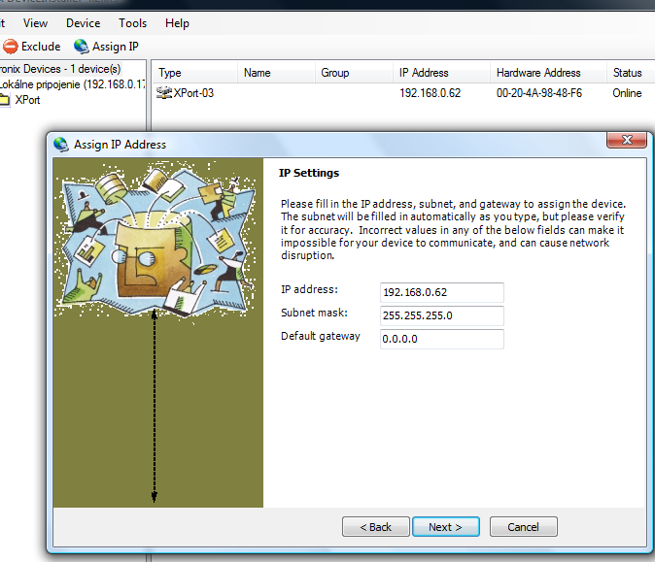

- Click on Assign button and new IP address will be set.

